

**COMP 6721**

Project Assignment - 2

**Spam Detector**

**Submitted to**

 Prof. Dr. René Witte

**Team name**

FL-G08

**TA and Marker**

Ms. Fathima Nihatha

**Team members**

|  |  |
| --- | --- |
| Apoorv Semwal | 40083939 |
| Ayush Dave | 40080515 |
| Mayank Jariwala | 40075419 |

Analysis

* **Flow Diagrams:** For **Evaluating** our Spam Classifier we tried both the **Unigram approach (with 2 different REGEX explained below)** and a **Bigram approach**.

Finally it was the **Unigram Approach with Regex-2** which gave us better results compared to other options.

**Training Flow:**

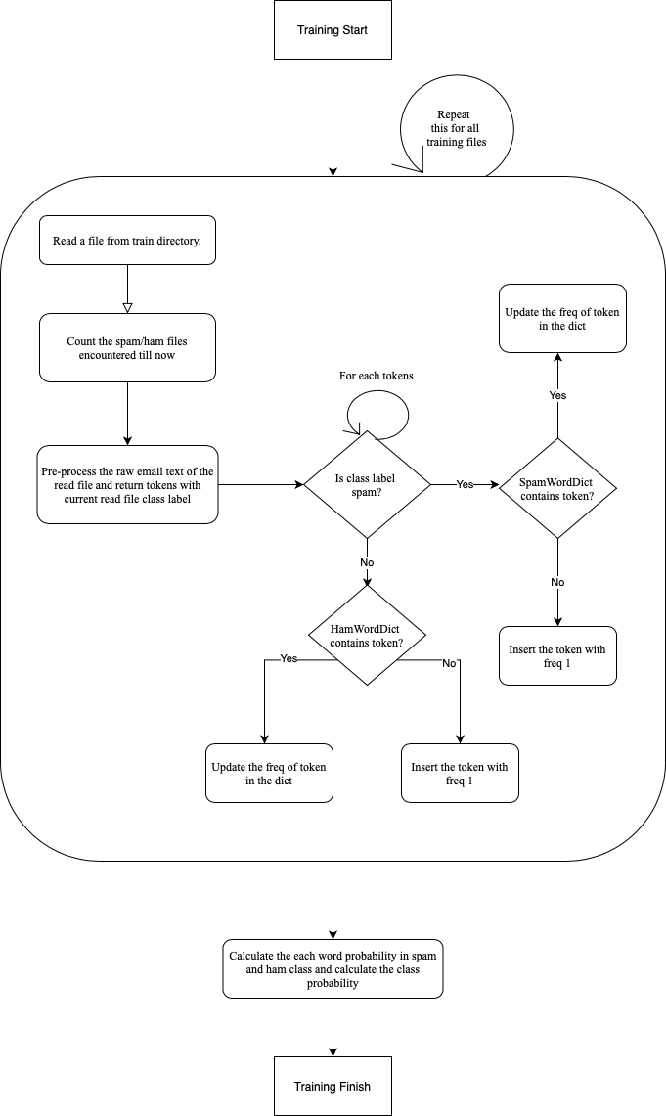

**Testing Flow:**

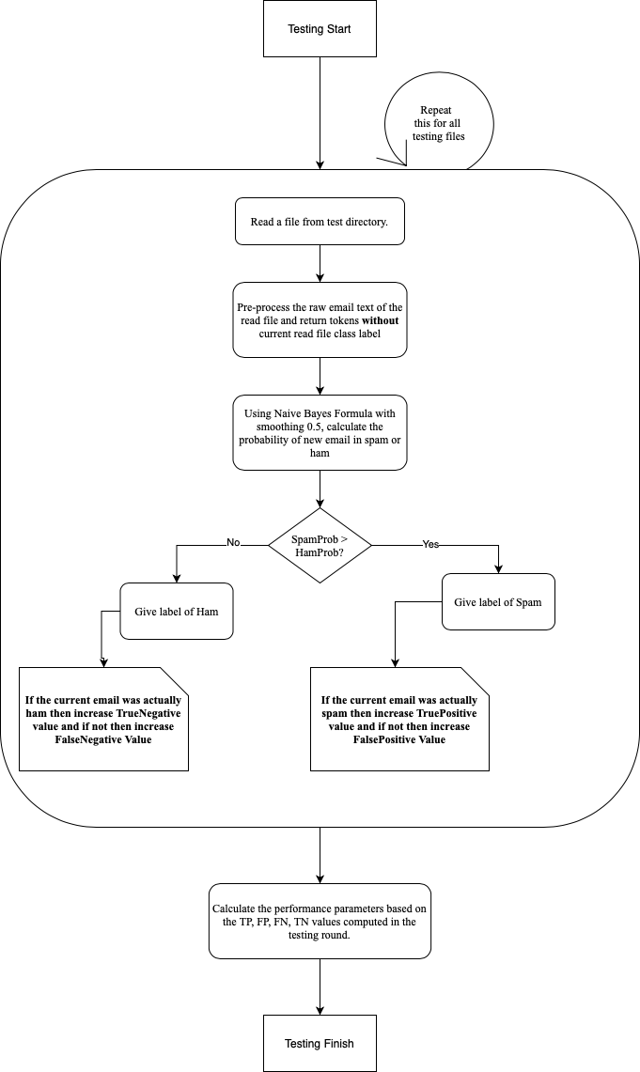

* **Problem formulation for training the Naïve Bayes Classifier:** Every single file provided within Training dataset **(1000 HAM and 997 SPAM),** was passed through a regular expression to split the file string and arrive a vocabulary of unique words. For splitting the file string we started our development with the regex provided in the problem statement, **‘[^a-zA-Z]’ i.e. split at every non-alphabet character.** However, we also tried checking if we could arrive at better results by slightly tweaking the regex to **'\W'** which is equivalent to **'[^a-zA-Z0-9_]' i.e. split at every non-alphanumeric character (except underscore).** We would be showing results for both.

* **REGEX-1:** **[^a-zA-Z]**
* **Vocabulary Size: 59251 Unique Words**
* **Confusion Matrix over Test Dataset:** Considering **SPAM as a positive class** and **HAM as the negative class**.

|  |  |  |  |
| --- | --- | --- | --- |
| *Test Files = 800* | **Predicted (Spam)** | **Predicted (Ham)** |  |
| **Actual (Spam)** | TP=364 | FN=36 | *400* |
| **Actual (Ham)** | FP=7 | TN=393 | *400* |
|  | *371* | *429* |  |

* **Evaluation Metrics:** Based on the above confusion matrix values following evaluation metrics were calculated.

**Accuracy**: TP + TN / (TP + TN + FP + FN)

**Recall**: TP / (TP + FN)

**Precision**: TP / (TP + FP)

**F1-Score**: 2 * Recall * Precision / (Recall + Precision)

|  |  |
| --- | --- |
| **Evaluation Metric** | **Value** |
| Accuracy | 94.625 |
| Precision | 98.113 |
| Recall | 91.0 |
| F1-Score | 94.423 |

* **REGEX-2:** **[^a-zA-Z0-9_] with unigram approach**
* **Vocabulary Size: 63480 Unique Words**
* **Confusion Matrix over Test Dataset:**

|  |  |  |  |
| --- | --- | --- | --- |
| *Test Files = 800* | **Predicted (Spam)** | **Predicted (Ham)** |  |
| **Actual (Spam)** | TP=366 | FN=34 | *400* |
| **Actual (Ham)** | FP=5 | TN=395 | *400* |
|  | *371* | *429* |  |

* **Evaluation Metrics:**

|  |  |
| --- | --- |
| **Evaluation Metric** | **Value** |
| Accuracy | **95.125** |
| Precision | **98.652** |
| Recall | **91.5** |
| F1-Score | **94.942** |

* **REGEX-2:** **[^a-zA-Z0-9_] With Bigram Approach:**

**\*Note:** Code for this has not been commited to the master branch and can be seen in a different branch – **‘bigram’ -** <https://github.com/apoorvsemwal/IntroToAI-SpamDetector/tree/bigram>.

* **Evaluation Metrics:**

|  |  |
| --- | --- |
| **Evaluation Metric** | **Value** |
| Accuracy | 14.375 |
| Precision | 0 |
| Recall | 0 |
| F1-Score | NA |

We obtained **best accuracy** for **Unigram Approach** with **Regex-2** - **[^a-zA-Z0-9_] - 95.125%**

For unigram with Regex-2 we also tried **removing the stop words** (frequently occurring words like this, the etc.) to check if it results in any improvement. However it resulted in a decrease in **accuracy – 84.75%. Code can be checked in branch ‘stop_words’ -** <https://github.com/apoorvsemwal/IntroToAI-SpamDetector/tree/stop_words>

Overall in general the Unigram with Regex-2 model was able to show very high Precision signifying that there is very high possibility of a mail being SPAM if our model predicts it to be a SPAM. This is desirable as we do not want our model to predict SPAM for a genuine mail.

However a slightly lower Recall signifies that in some 9% of the cases model might not classify a mail as SPAM at all while the mail was actually a SPAM.

References

1. <https://stackoverflow.com/questions/28931224/adding-value-labels-on-a-matplotlib-bar-chart>
2. <https://stackoverflow.com/questions/265960/best-way-to-strip-punctuation-from-a-string>

**Instructions to run the project:**

* Download/Clone the Project Repo to your local machine –

[IntroToAI-SpamDetector](<https://github.com/apoorvsemwal/IntroToAI-SpamDetector.git>)

or access it from Google drive – (<https://drive.google.com/open?id=1hFeO5xocprJfMTZcDSfcwEt-uOsAlrHS>)

* Navigate to **'\IntroToAI-SpamDetector\src'** in your terminal
* Run CMD:

**python launcher.py**

* Check results folder **'\IntroToAI-SpamDetector\results'**